

 | Raizia mam
rh | Garikipati keerthi
 | 2520030416
 | CSE

: n this case study, we implemented an Intelligent Hospital Management System called HealthNet to manage hospital operations efficiently. The system stores patient records, doctor details, appointments, billing information, and room allocations in a centralized database. The system reduces manual paperwork, improves data retrieval speed, and enhances patient care through automated management processes.
We inserted patient and doctor records, scheduled appointments, managed room allocations, and generated billing reports. The system supports fast searching, updating, and retrieval of records while maintaining data accuracy and security

6.
Result: Screenshots / Output
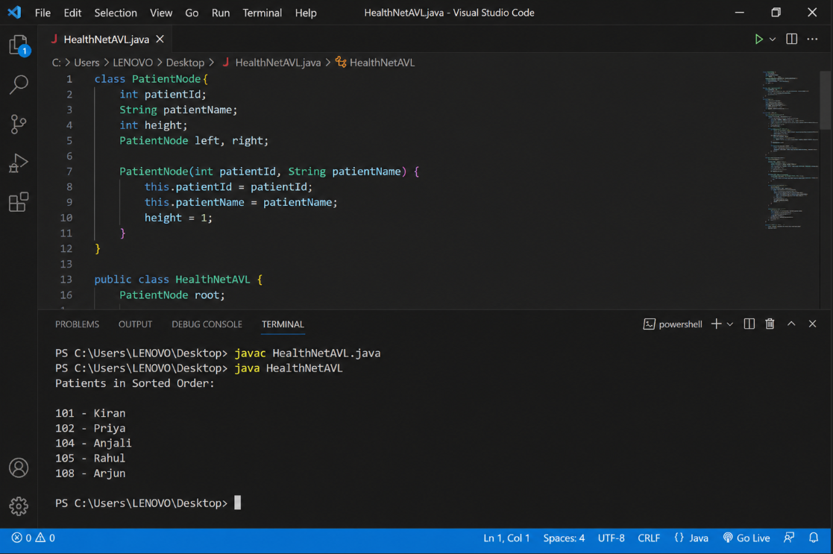

Implementation Details:
1. Added patient records including Patient ID, Name, Age, Disease, and Contact Information.
2. Stored doctor details such as Doctor ID, Name, Department, and Availability.
3. Implemented appointment scheduling between patients and doctors.
4. Managed hospital room and bed allocation for admitted patients.
5. Generated billing records based on treatment and room charges.
6. Implemented search functionality for quick retrieval of patient and doctor information.
7. Maintained centralized database for secure storage and management.
8. Generated reports for hospital administration and patient management

Gitbub link- https://github.com/keerthig26

Student signature | Faculty signature

